Project Design Phase 1 – Problem Solution Fit

|  |  |
| --- | --- |
| **Project Domain** | Data Analytics |
| **Project Title** | Visualizing and Predicting Heart Diseases with an Interactive Dash Board |
| **Team ID** | PNT2022TMID44369 |
| **Date** | 1st Oct 2022 |

***Problem Solution Fit:***

The Problem-Solution Fit simply means that you have found a problem with your customer and that the solution you have realized for it actually solves the customer’s problem

Step-1: Business Problem

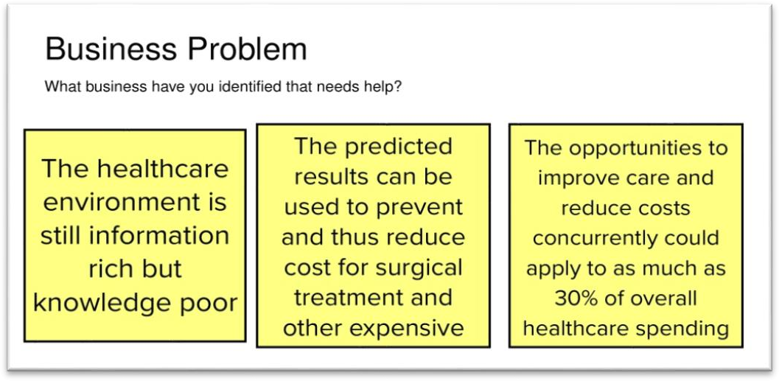

Step-2: Business Outcomes

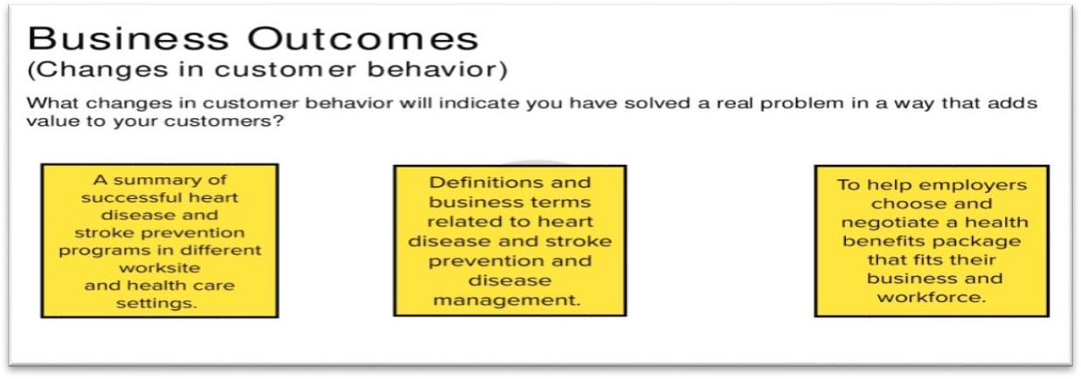

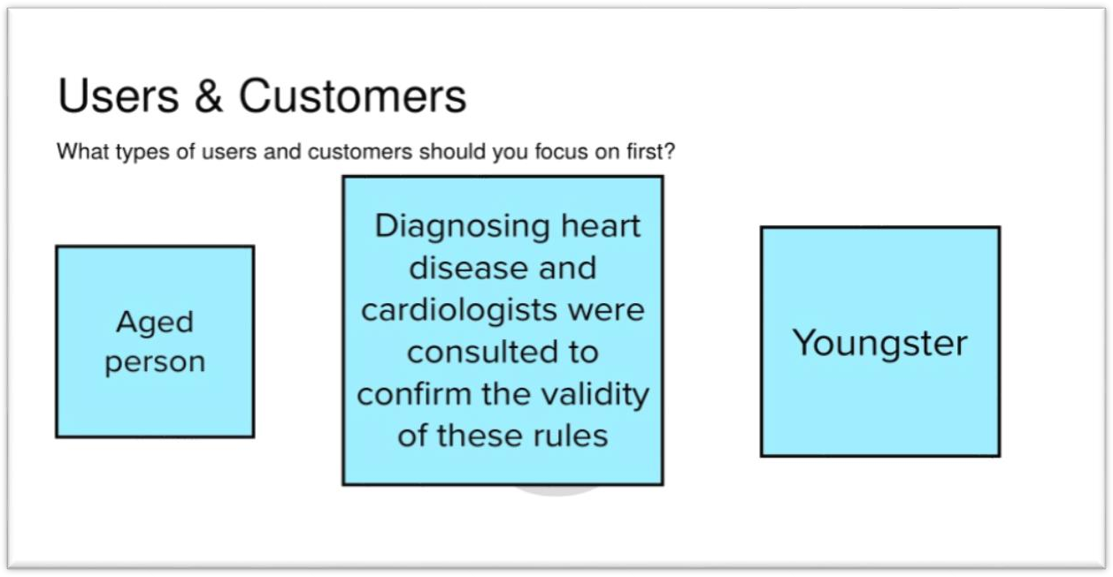

Step-4: User Benefits

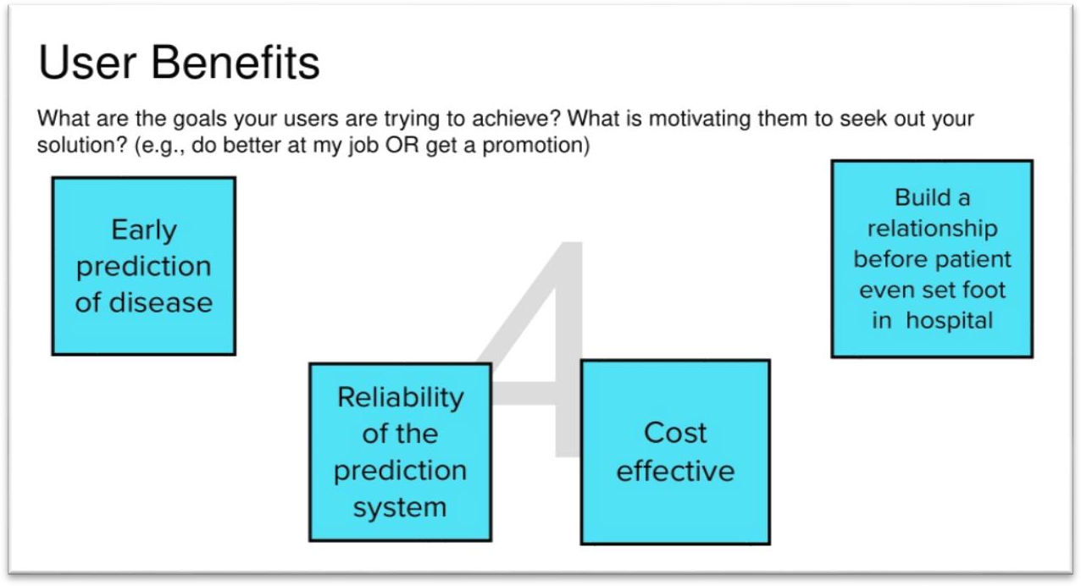

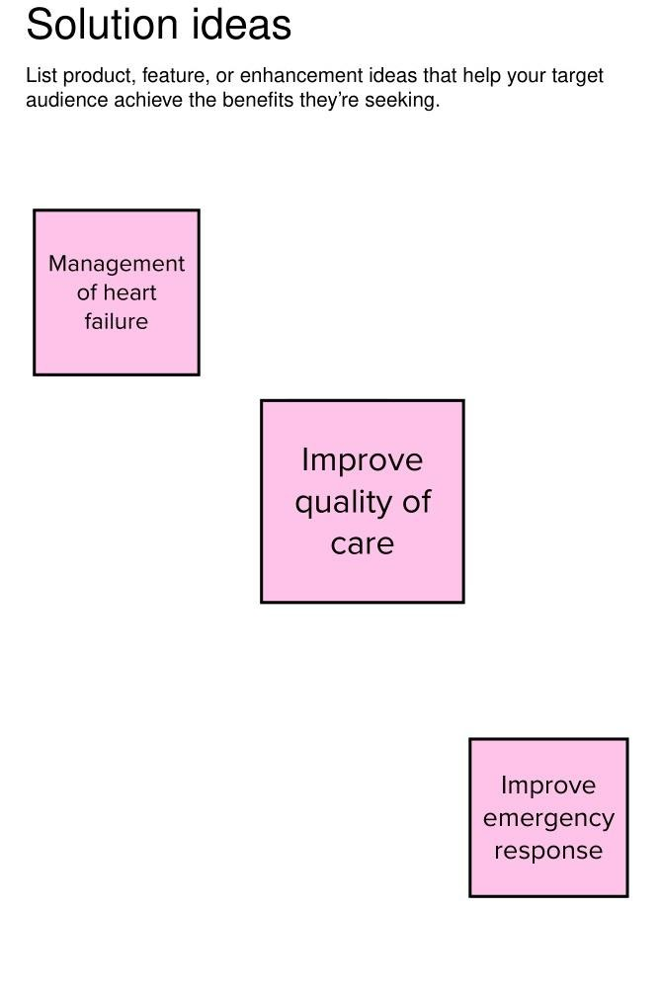

Step-6: Solution Ideas-2

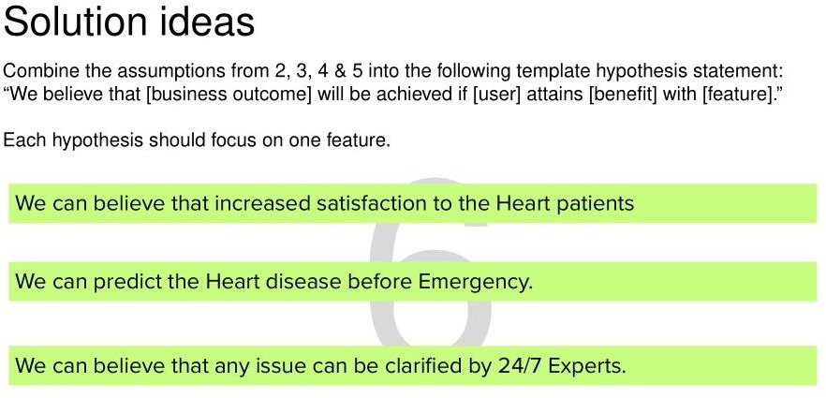

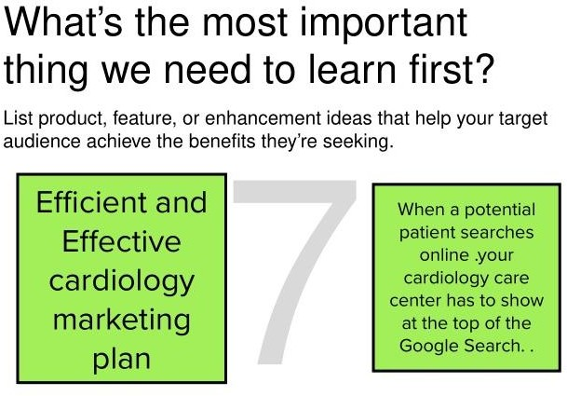

Step-8: What’s the least amount of work we need to do learn the next most important thing?

